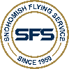 SNOHOMISH FLYING SERVICE

Precision Flight Controls Modular Flight Deck AAFTD

_________________________________________________________

***Single and Multi-Engine Operations***

***Low Profile Panel for VFR and IFR***

***Modular Flight Deck***

***Backlit Panels***

***Nation Wide Visual***

***External Visual System***

***Dynamic Weather Conditions***

***Nation Wide Navigational Data Base***

***System Failures***

***Maps***

***\*Use FTD in the Private, Commercial, Instrument, CFI and Multi-Engine Courses***

***\*\*Approved for 40% of the training conducted under SFS’s FAR 141 Instrument Course (14 hours)***

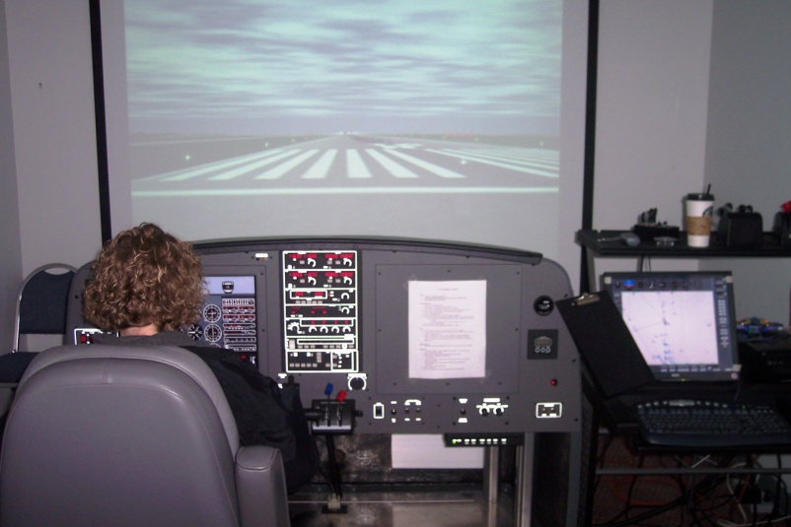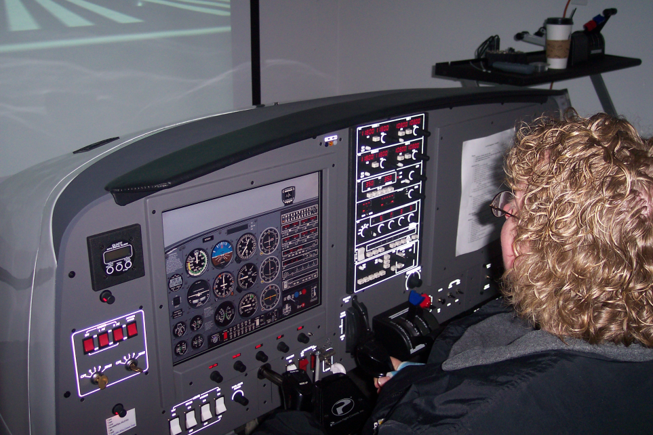 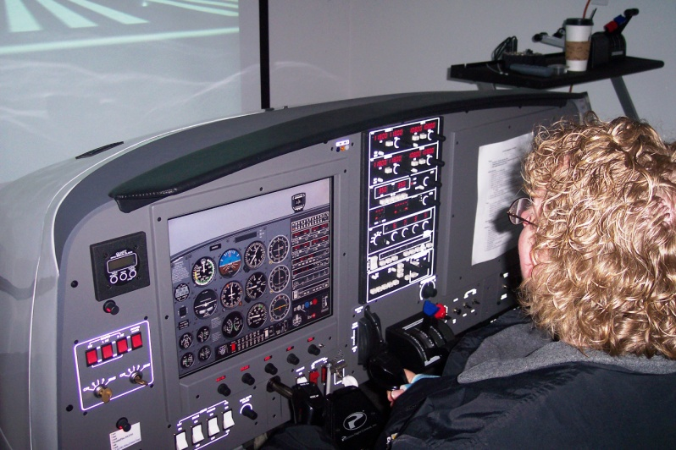

***Precision Flight Controls Modular Flight Deck Flight Training Device (FTD)***

